🧪 MLMIS - Medical Laboratory Management System
A secure, modern, and all-in-one software designed to digitize your laboratory's daily operations. From patient registration to automated WhatsApp report delivery, MLMIS handles everything in one place.

✨ Key Features
👥 Patient Management
* Generate unique **MR Numbers** for every patient.
* View complete patient profiles, including medical history and billing history.
🧬 Test Catalog & Result Entry
* Fully customizable test catalog (e.g., CBC, LFT, RFT).
* Enter patient results manually, with automatic **High/Low abnormal
💰 Billing & Finance
* Generate invoices, apply discounts, and record full/partial payments.
* Track daily expenses (Rent, Salaries, Supplies) and view a complete financial dashboard.
📱 Patient Portal (No Login Required)
* Patients don't need to create passwords.
* They simply select **"Patient Portal"** on the login screen and enter their **MR Number** and **Name** to view and print their reports

Dashboard
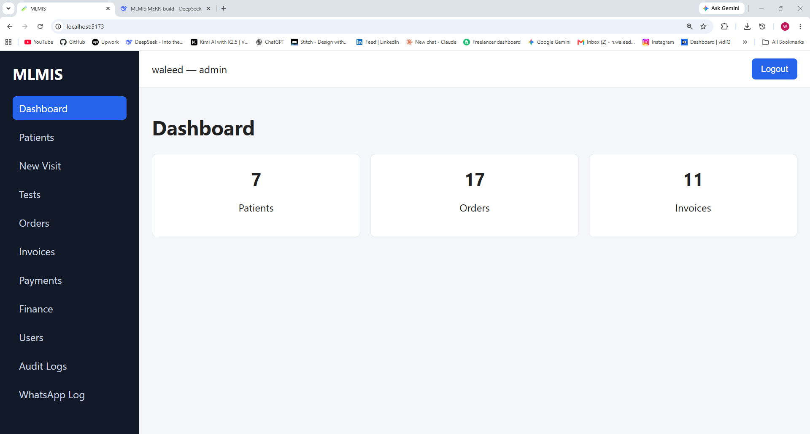

Patients
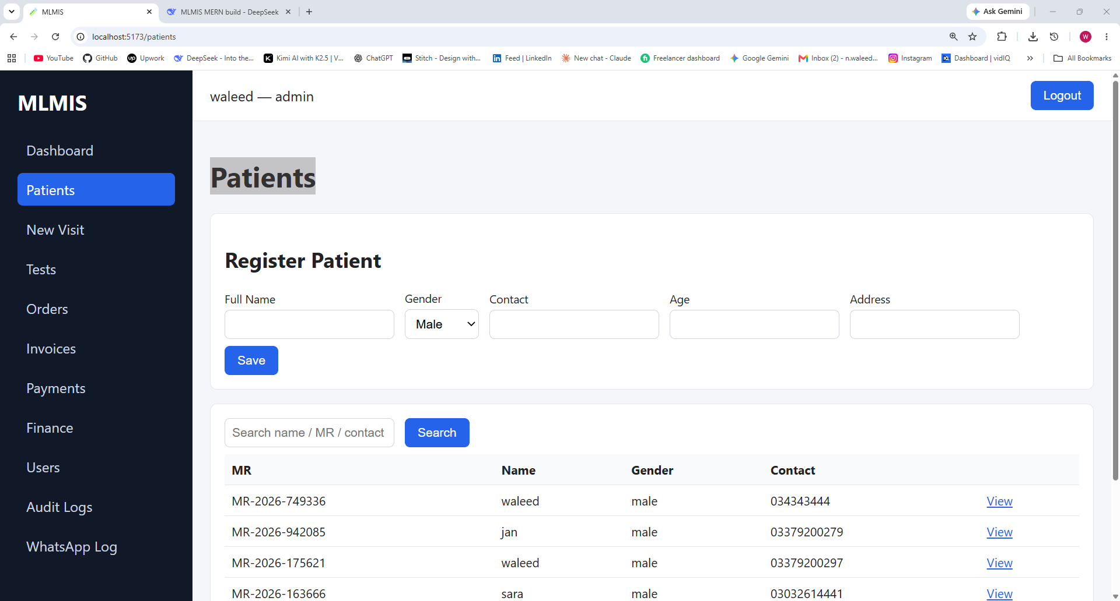

New Visit
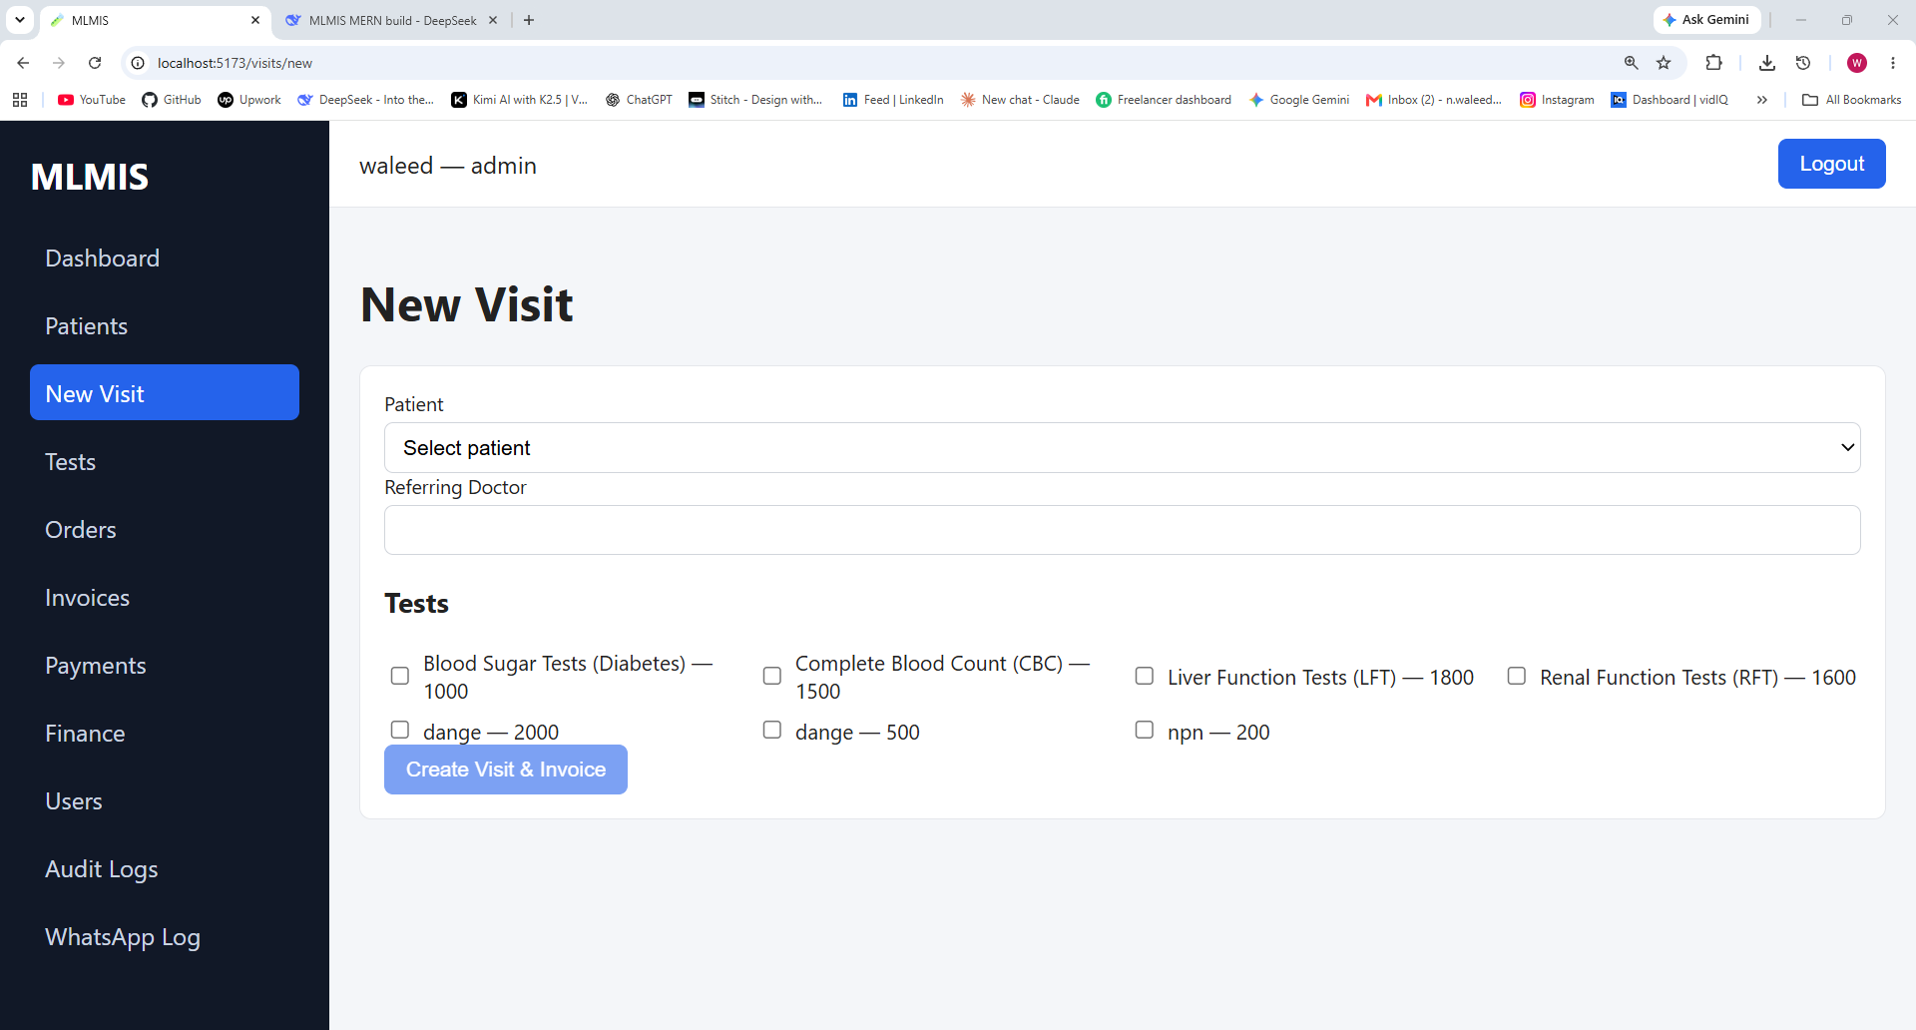

Test Catalog
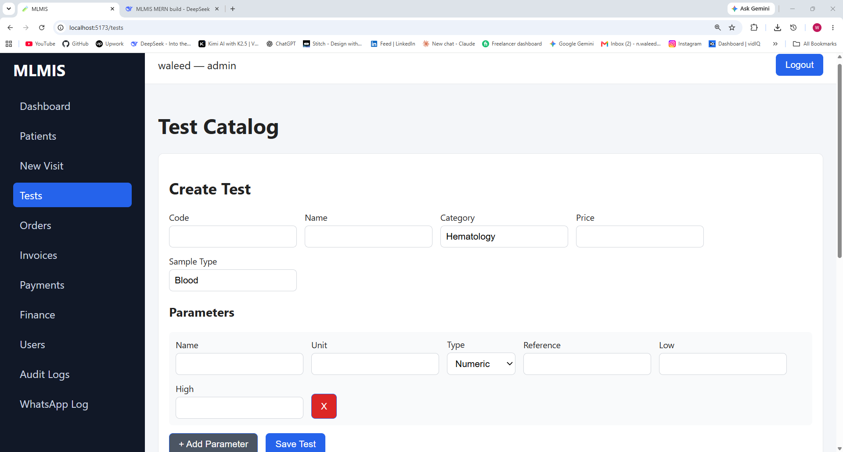
Orders
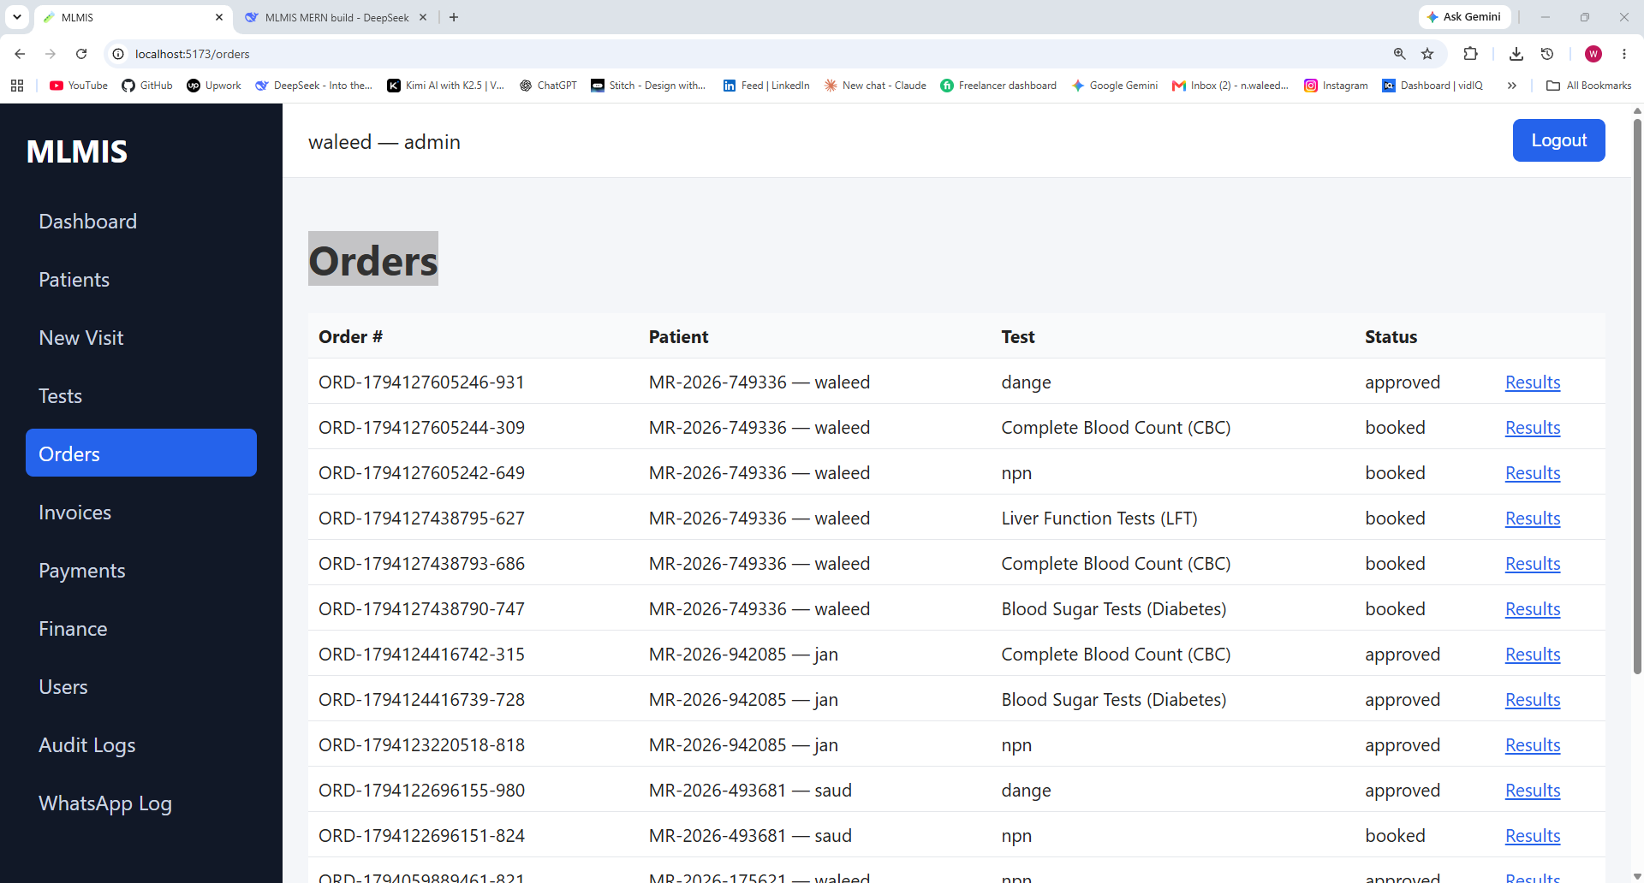

Invoices
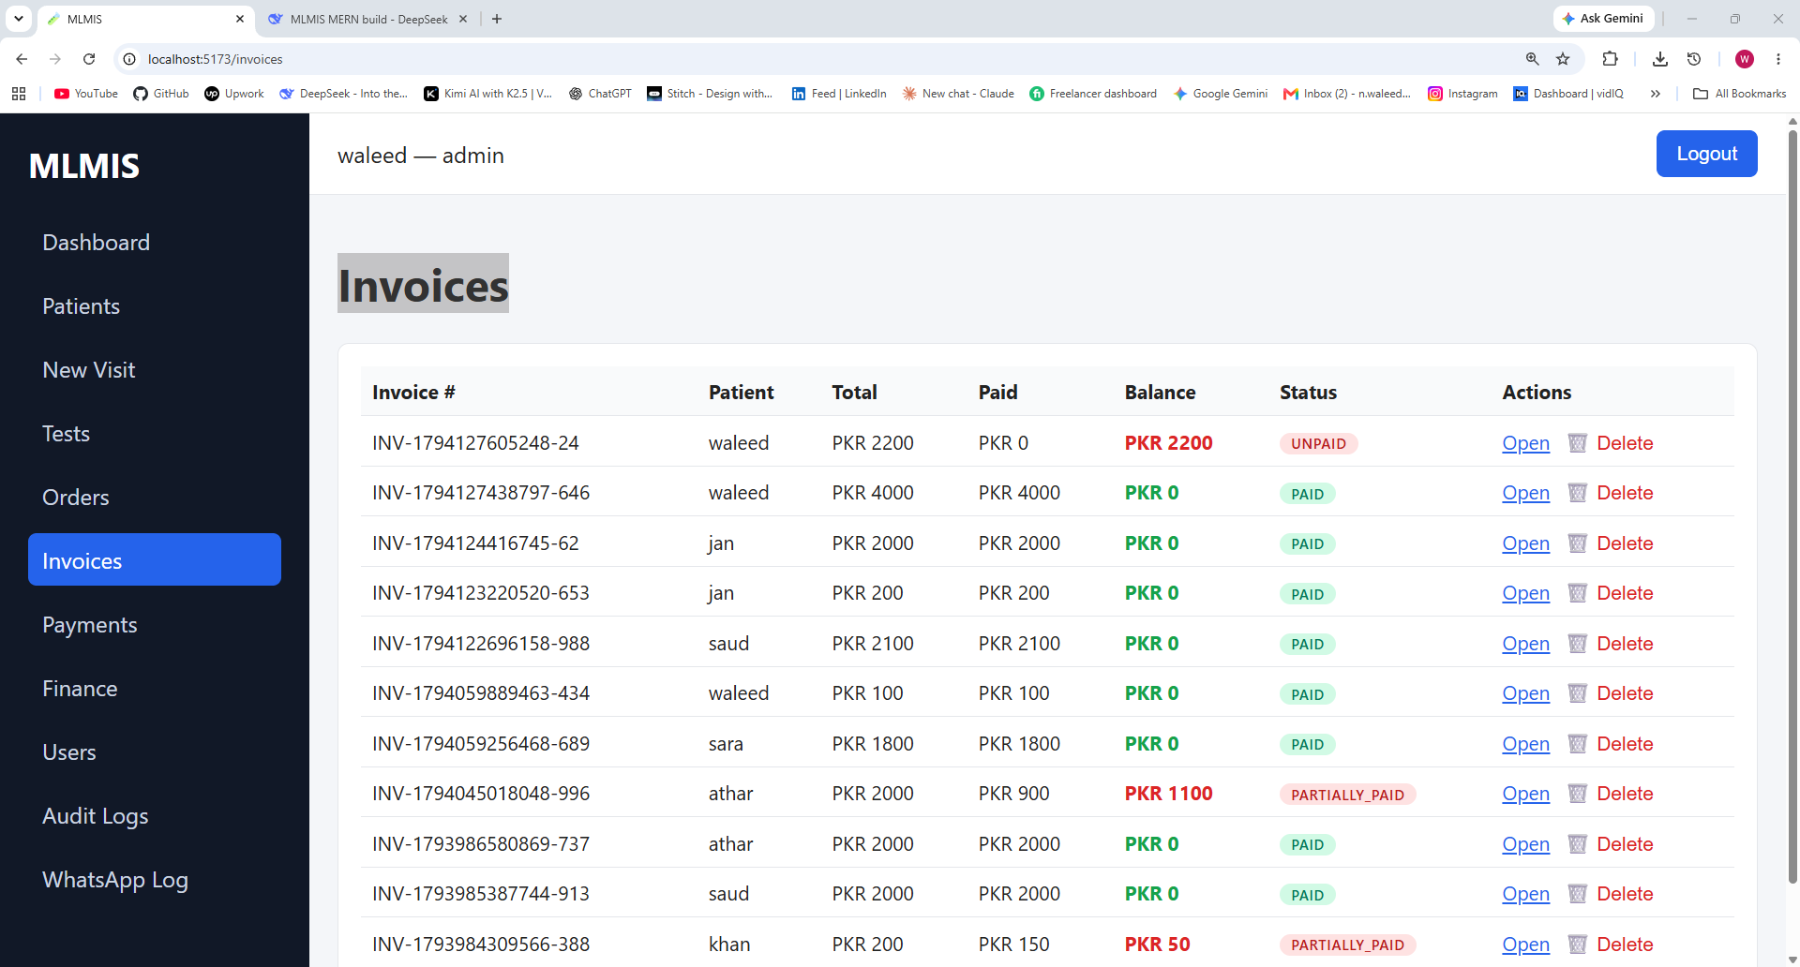
All Payments
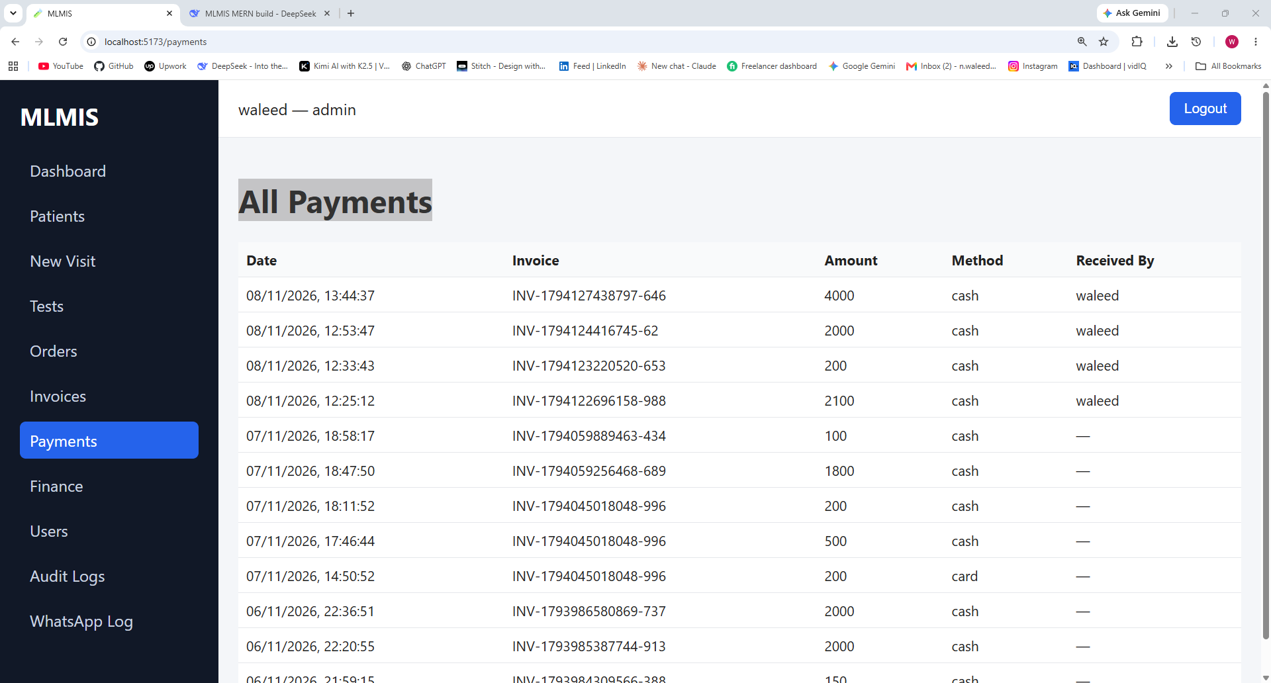

Financial Dashboard
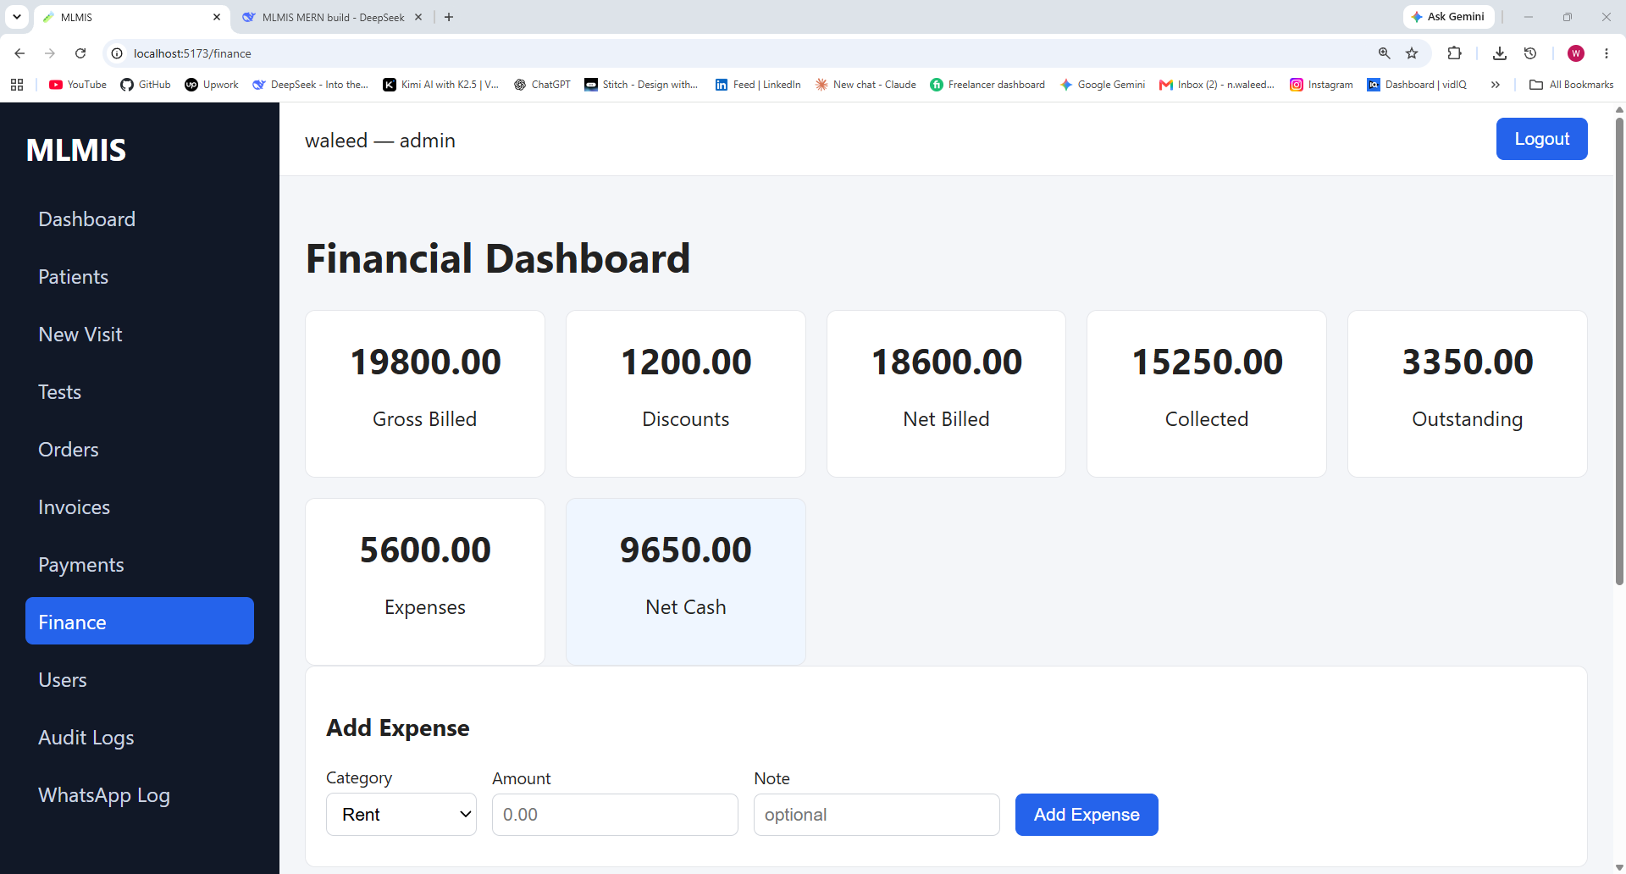
Patient Profile

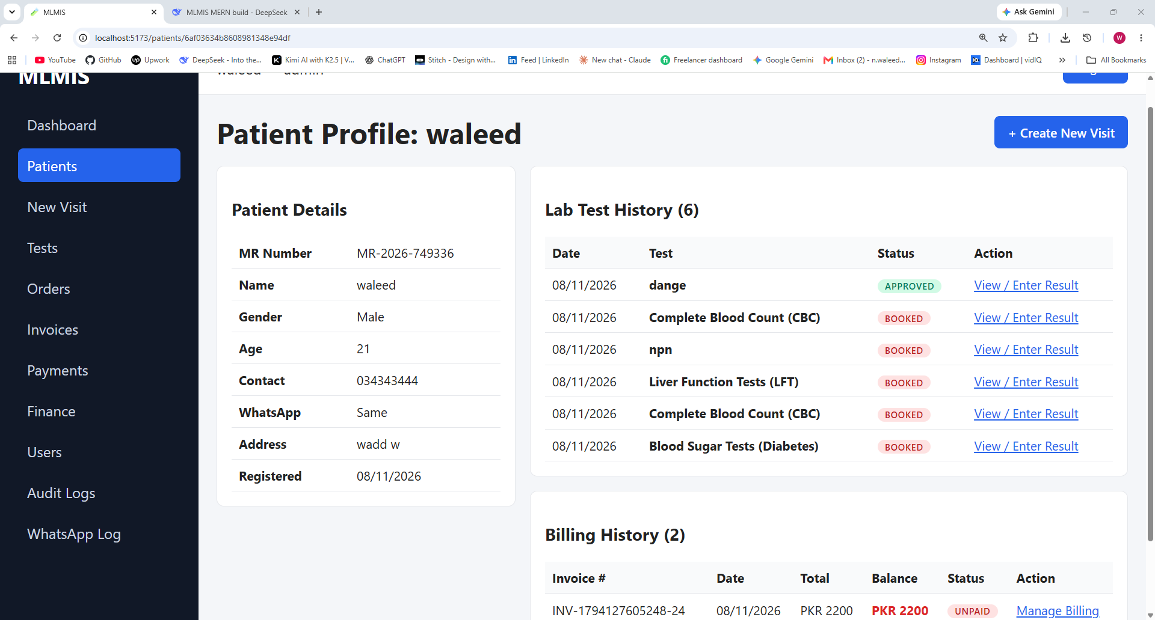
Result Entry
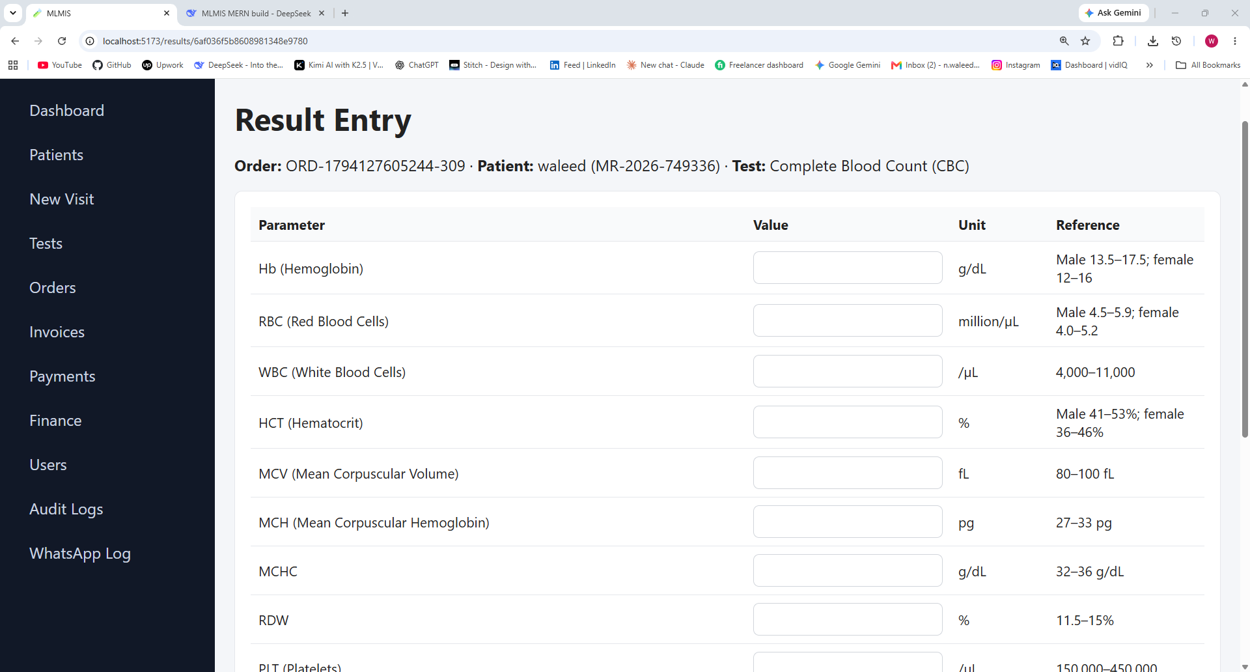

RESULT


